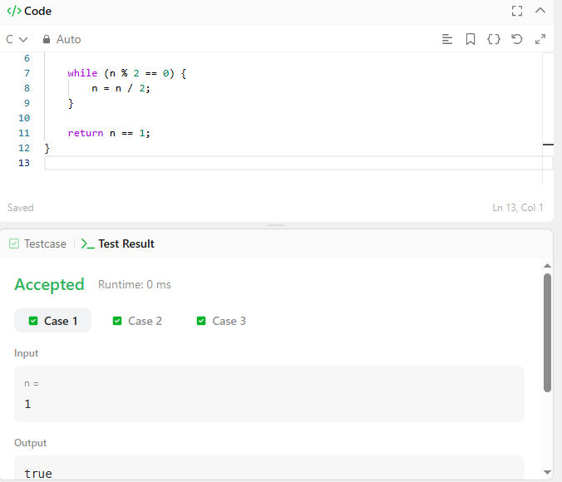

CODE –
bool isPowerOfTwo(int n) {
if (n <= 0) {
return false;
}

while (n % 2 == 0) {
n = n / 2;
}

return n == 1;
}

LINK –
https://leetcode.com/problems/power-of-two/

